**Do Users Rate or Review? Boost Phrase-level Sentiment**

**Labeling with Review-level Sentiment Classification**

1. INTRODUCTION

In general the framework is two-stage. In the first stage, the overall sentiment orientations of the product reviews are labeled using a review-level sentiment classifier. In the second stage, we extract feature-opinion pairs from the corpus, then use the overall sentiment orientations of the reviews as constraints to learn the sentiment polarities of these pairs automatically, using a novel optimization framework.

2. THE FRAMEWORK

2.1 Review-Level Sentiment Classification

2.2 Sentiment Lexicon Construction

We consider four kinds of constraints to learn the sentiment lexicon X: 1) Review-level sentiment orientation, 2) General sentiment lexicon, 3) Linguistic heuristics, and 4) Sentential sentiment consistency.

1) Review-level Sentiment Orientation

2) General Sentiment Lexicon

3) Linguistic Heuristic

4) Sentential Sentiment Consistency

2.3 The Unified Model for Polarity Labeling

3. EXPERIMENTS

3.1 User Rating Analysis

For the overall rating and each sub-aspect rating, we calculate the percentage that each of the 5 star ratings takes in the total number of ratings, shown in Figure 2. The x-axis represents 1 star through 5 stars, and the y-axis is the percentage of each star rating.

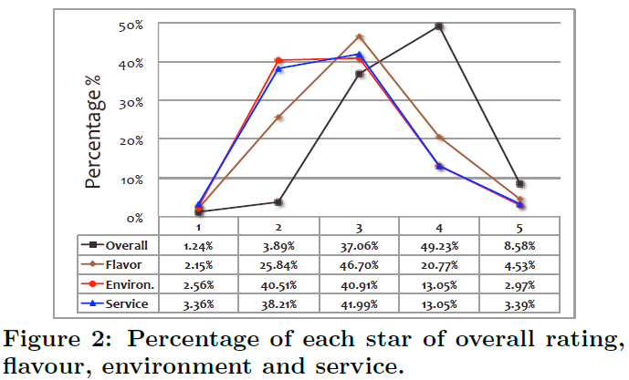

In order to examine the statistical significance, we calculate the average rating _ and coefficient of variation cv = _=_ for the overall rating and the three sub-aspect ratings, where is the standard deviation. Table 2 shows the results. We see that users tend to give higher scores on overall rating, and the scores on overall rating are more concentrated.

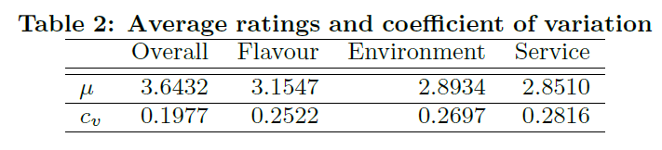

More intuitionally, we conduct per user analysis. For each user and each kind of rating (overall, flavour, environment and service), we calculate the percentage of 4 or 5 stars that the user made.

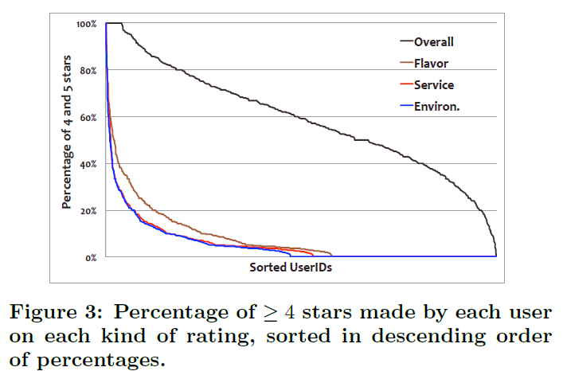

This analysis partly shows that it might not be appropriate to use overall ratings as ground truth to label the sentiment orientations of review texts, as users tend to act differently when making overall ratings and expressing their true feelings on detailed product features/aspects.

3.2 Phrase-Level Polarity Labeling

3.3 Parameter Analysis

4. CONCLUSIONS AND FUTUREWORK